Experiment / Case Study 6

Experiment Title: Use string functions and regex for email validation, data extraction, and text analysis.
Software / Tools Required: VS Code, JavaScript, HTML/CSS, Web browser
Experiment Program Code:
StringAndRegex.html (HTML/CSS File)
<!DOCTYPE html>
<html>
<head>
<meta charset="UTF-8">
<title>String Methods and Regular Expressions</title>
<style>
body {
font-family: Arial, Helvetica, sans-serif;
margin: 40px;
}

h1 {
text-align: center;
}

.box {
border: 1px solid black;
background-color: rgba(255, 174, 0, 0.8);
backdrop-filter: blur(15%);
padding: 20px;
margin-top: 20px;
border-radius: 10px;
box-shadow: 0 3px 6px rgba(0, 0, 0, 0.1);
}

input, textarea{
padding: 10px;
margin: 5px 0;
width: 90%;
box-shadow: 0 1px 2px rgba(0, 0, 0, 0.1);
}

button {
color: white;
width: 150px;
cursor: pointer;
font-size: 15px;
padding: 10px;
margin: 5px 0;
border-radius: 8px;
background-color: rgb(240, 14, 14);
transition: transform 0.15s ease, background-color 0.15s ease;
}

button:hover {
background-color: rgb(208, 15, 15);
transform: scale(1.05);
}

#output {
margin-top: 20px;
padding: 15px;
background-color: rgb(24, 179, 127, 0.8);
background-clip: blur(15%);
text-shadow: 0 3px 6px rgba(0, 0, 0, 0.1);
border-radius: 10px;
}
</style>
</head>
<body style="background-image: linear-gradient(to bottom, rgb(243, 179, 39), yellow);">
<h1>String Methods and Regular Expressions</h1>
<div class="box">
<label><b>Enter a paragraph: </b></label><br>
<textarea id="para" rows=5 placeholder="Lorem ipsum..."></textarea>
<br><br>
<label><b>Enter Email: </b></label><br>
<input type="text" id="email" placeholder="johndoe@email.com">
<br><br>
<label><b>Find and Replace</b></label><br>
<input type="text" id="find">
<input type="text" id="replace">
<br><br>
<button onclick = "processString();"><b>Process</b></button>
</div>
<div class="output" id="output"></div>
<script src="StringScript.js"></script>
<h3>Designed By Arunima Das, PRN: 24070521007</h3>
</body>
</html>
StringScript.js (JavaScript File)
function processString() {
para = document.getElementById('para').value;
email = document.getElementById('email').value;

let words = para.split(/\s+/);

let vowels = para.match(/[aeiouAEIOU]/gi);

let v_count = vowels ? vowels.length : 0;

let searchWord = document.getElementById('find').value;

let replaceWord = document.getElementById('replace').value;

let position = para.indexOf(searchWord);

let replacedPara = "";

if(replaceWord) {
const s_regex = new RegExp(searchWord, "g");
replacedPara = para.replace(s_regex, replaceWord);
} else {
replacedPara = "None";
}

let emailRegex = /^[a-zA-Z\d._+%-]+@[a-zA-Z\d.-]+\.[a-zA-Z]{2,}$/;
let emailResult;

if(emailRegex.test(email)) {
emailResult = "Valid Email Address";
}
else {
emailResult = "Invalid Email Address";
}

//let emailText = 'For queries contact student@example.com or educator@example.edu';

let extractedEmails = para.match(/[a-zA-Z\d._+%-]+@[a-zA-Z\d.-]+\.[a-zA-Z]{2,}/g);

let reversedPara = para.split("").reverse().join("");

document.getElementById('output').innerHTML =
`
<h3>1. Original Paragraph</h3>
<p>${para}</p>

<h3>2. split() - Words</h3>
<p>${words.join(", ")}</p>

<h3>3. match() - Vowels</h3>
<p>${vowels ? vowels.join(", ") : "No vowels found"}</p>

<h3>4. Vowel Count</h3>
<p>Total number of vowels: <b>${v_count}</b></p>

<h3>5. indexOf() - Search Word</h3>
<p>
Position of "<b>${searchWord}</b>":
<b>${position}</b>
</p>

<h3>6. replace() - Replaced Text</h3>
<p>${replacedPara}</p>

<h3>7. Email Validation using Regex</h3>
<p>
Email: <b>${email}</b><br>
Result: <b>${emailResult}</b>
</p>

<h3>8. Extracted Emails by Regex</h3>
<p>
${extractedEmails ? extractedEmails.join("<br>") : "No email addresses found"}
</p>

<h3>9. Reversed Paragraph</h3>
<p>${reversedPara}</p>
`
}
Output:
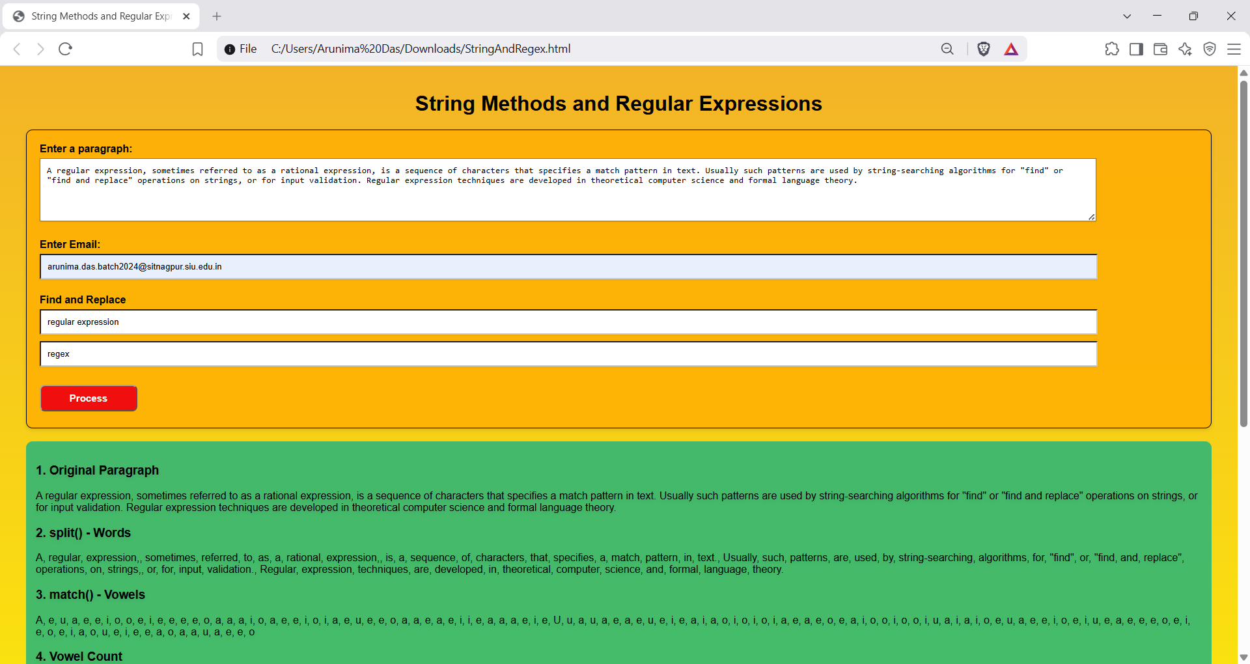
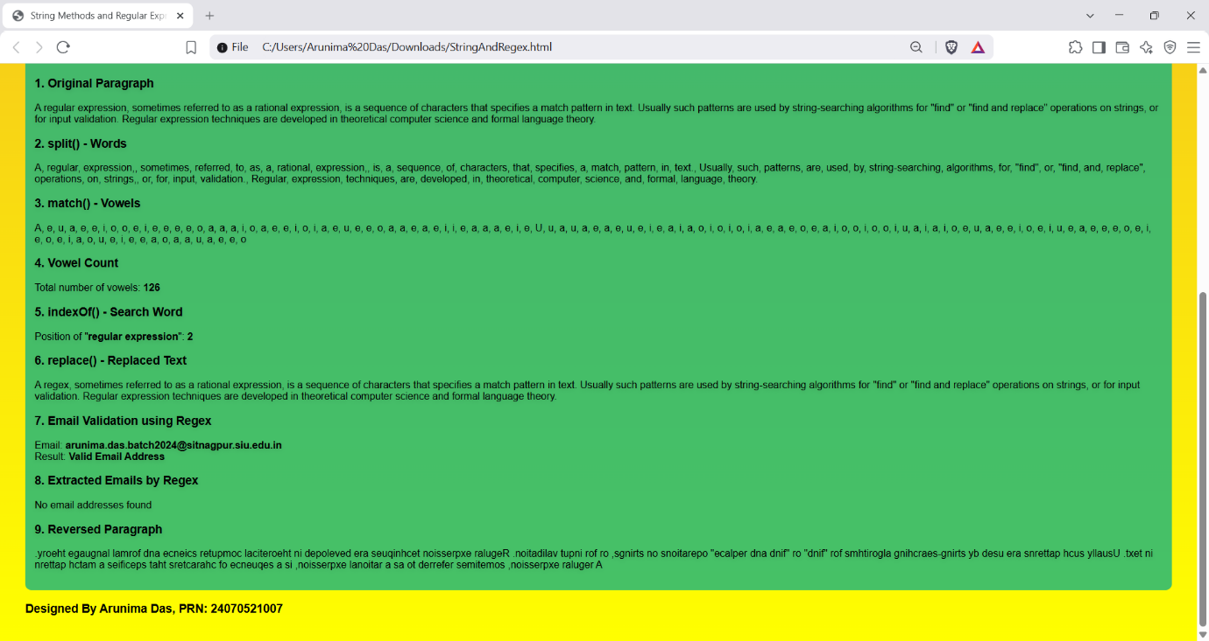
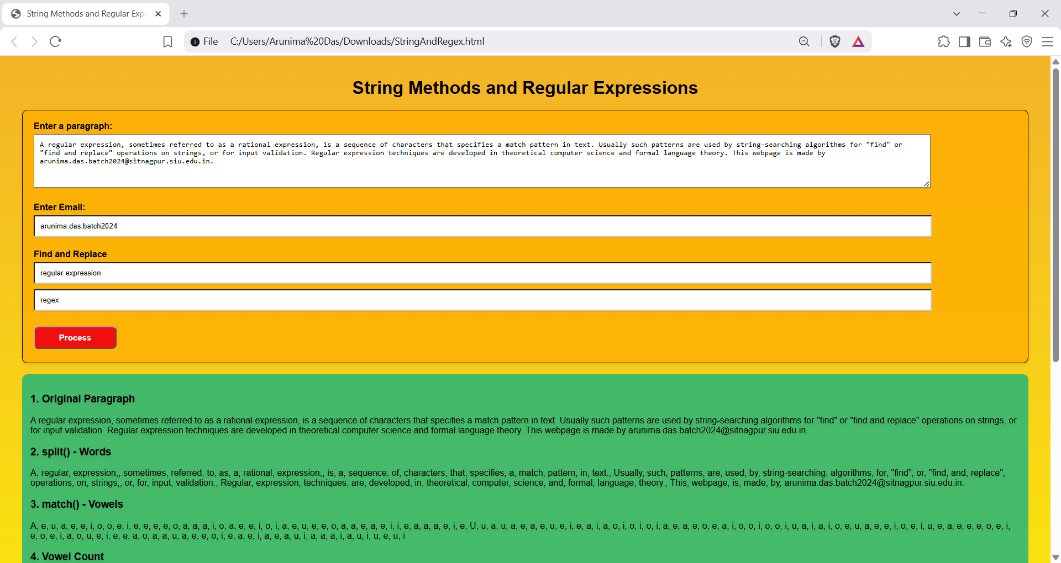
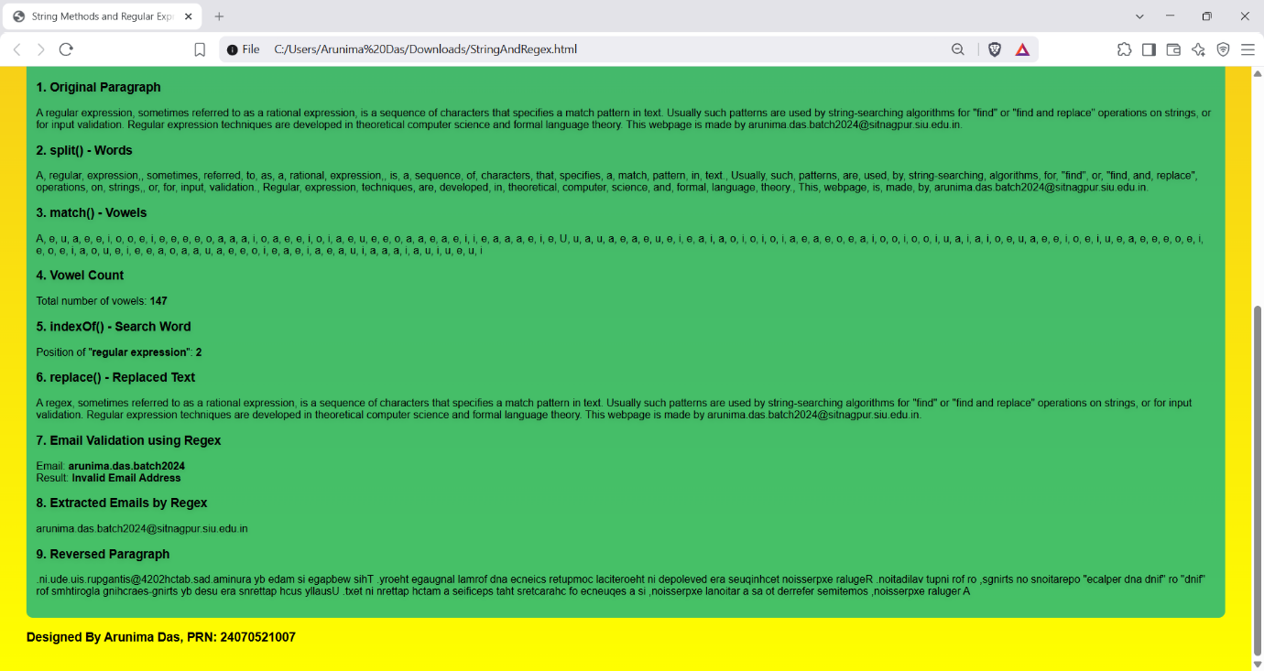
Case Study Title: Take a string and paragraph as input. Reverse the string and count the vowels in the paragraph.
Case Study Program Code:
ReverseAndVowel.html (HTML/CSS File)
<!DOCTYPE html>
<html>
<head>
<meta charset="UTF-8">
<title>Bot Detector</title>
<style>
body {
background-color: #1DA1F2;
text-align: center;
}

h2, h3 {
font-family: 'Gill Sans', 'Gill Sans MT', Calibri, 'Trebuchet MS', sans-serif;
color: white;
}

.card {
border: 3px solid transparent;
text-align: center;
padding: 10px;
margin-top: 25px;
width: max-width;
background: #1DA1F2;
background: linear-gradient(90deg, rgba(255, 255, 255, 0.4), rgba(255, 255, 255, 0.1)) padding-box;
background: linear-gradient(45deg, rgba(255, 255, 255, 0.5), rgba(255, 255, 255, 0)) border-box;
border-radius: 15px;
backdrop-filter: blur(20px);
box-shadow: 0 4px 8px rgba(0, 0, 0, 0.1);
}

label {
font-family: 'Gill Sans', 'Gill Sans MT', Calibri, 'Trebuchet MS', sans-serif;
color: white;
font-size: 20px;
text-shadow: 0 1px 2px black;
}

input, textarea {
margin-top: 10px;
width: 50rem;
border-radius: 8px;
box-shadow: 0 1px 2px black;
}

button {
margin-top: 10px;
background-color: #0b5a8b;
font-size: 20px;
font-family: 'Gill Sans', 'Gill Sans MT', Calibri, 'Trebuchet MS', sans-serif;
color:white;
border-radius: 8px;
box-shadow: 0 1px 2px black;
}
</style>
</head>
<body>
<h2>Is This Account A Bot?</h2>
<div class="card">
<label>Enter its bio</label><br>
<input type="text" id="bio">
<br><br>
<label>Enter the content of one of its posts</label><br>
<textarea rows="5" id="post"></textarea>
<br><br>
<button onclick="checkIfBot();">Submit</button>
</div>
<div id="output"></div>
<script src="BotCheckScript.js"></script>
</body>
</html>
BotCheckScript.js (JavaScript File)
function checkIfBot() {
let str = document.getElementById('bio').value;
let para = document.getElementById('post').value;

let rev_str = str.split("").reverse().join("");

let vowels = para.match(/[aeiouAEIOU]/g);
let v_count = vowels ? vowels.length : 0;

let para1 = para.replace(/ /g, "");
let char_count = para1.length;
let con_count = char_count - v_count;

let ratio = (v_count / char_count)*100;
let result;

if(ratio < 40.0) {
result = "Potential spam bot!"
}
else {
result = "Likely safe"
}

document.getElementById('output').innerHTML =
`
<h3>Reversed bio:</h3>
<b>${rev_str}</b>
<br><br>
<h3>Number of vowels in the post: </h3>
<b>${v_count}</b>
<br><br>
<h3>Vowel-To-Consonant Ratio: </h3>
<b>${ratio.toFixed(2)}</b>
<br><br>
<h3>Result: </h3>
<b>${result}</b>
`

console.log(v_count);
}
Output:
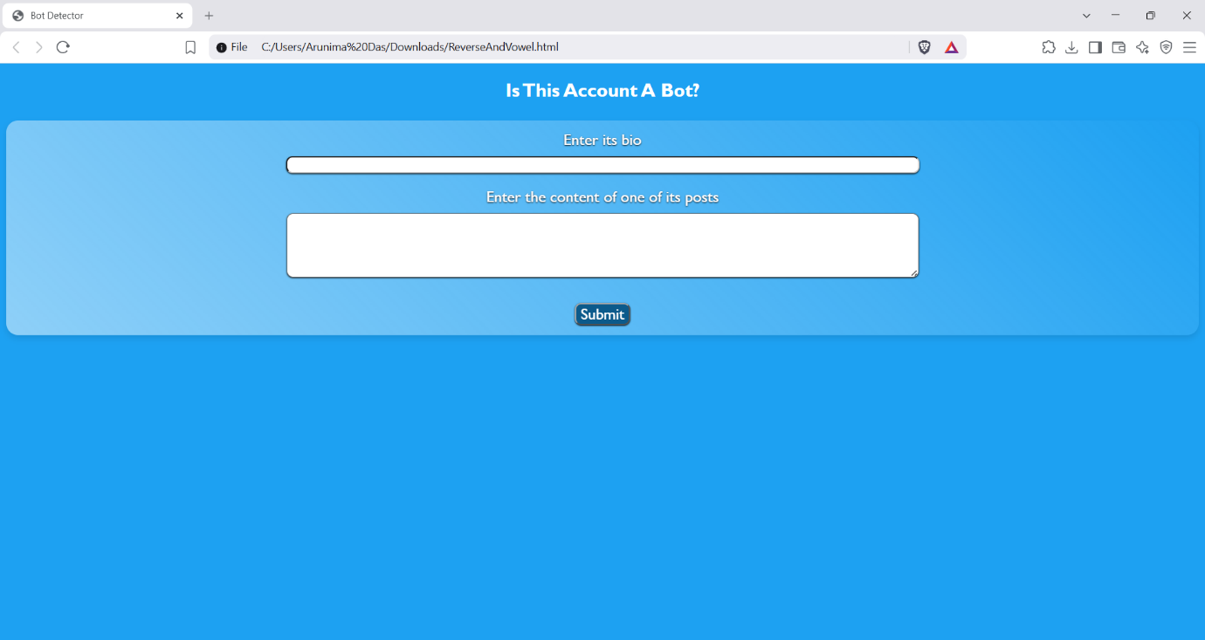
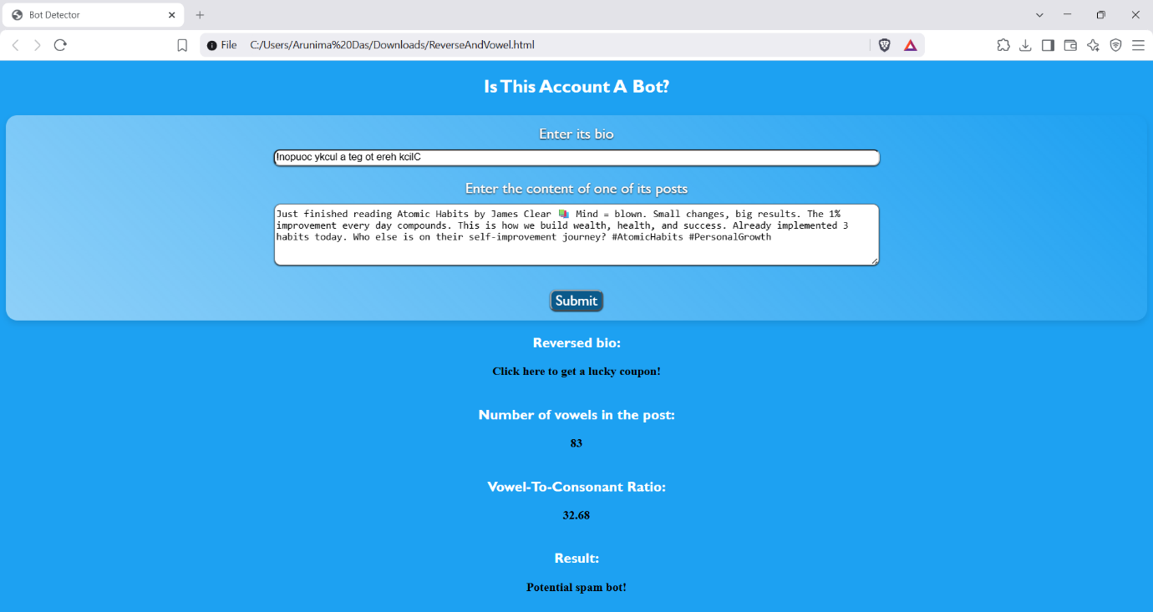
Conclusion: Thus, by using string methods and regular expressions, we can perform validation of text elements for analysis, as well as data extraction.

